II B. Tech I Semester Regular Examinations - December, 2023
DATABASE MANAGEMENT SYSTEMS
(CSE/CSE(CS)/CSE(DS)/CSE(AI&ML)
Time: 150 Min Max. Marks:80M

SECTION – A
Answer all Four questions 4×10M=40M

  - Why would you choose a database system instead of simply storing data in operating system files?
  - With an example describe schema and instances in a Database.
  - If you were designing a Web-based system to make airline reservations and sell airline tickets, which DBMS architecture would you choose? Why?
  - Compare and Contrast an entity, an entity type, and an entity set.
2.
a. Discuss the role of redundancy in the DBMS
- Describe the three-scheme architecture. Why do we need mappings among schema levels?
- Consider the following schema:
Suppliers (sid: integer, sname: string, address: string)
Parts (pid: integer, pname: string, color: string)
Catalog (sid: integer, pid: integer, cost: real)
State what the following queries compute:
  - Parts Catalog Suppliers
  - Parts Catalog Suppliers
  - Parts Catalog Suppliers
3.
a. What does the term normalization refer to? How to achieve it?
b. Draw a state diagram and discuss the typical states that a transaction goes through during execution.
c. Determine whether the decomposition of R into R1(A, B), R2(B, C) and R3(B, D) is lossless or lossy.
4.
a. Define these terms: atomicity, consistency, isolation, durability.
b. Contrast Catastrophic and Non-Catastrophic failures and discuss how to handle them.
c. Why should NULLs in a relation be avoided as much as possible? Discuss the problem of spurious tuples and how we may prevent it.
d. Discuss the actions taken by the read_item and write_item operations on a database with an example.
SECTION - B
Answer all Two questions 2×20M=40M
5.
  - Evaluate the given ER diagram for a university database. Identify and discuss any design strengths, weaknesses, or normalization concerns. Propose specific modifications or enhancements to improve the overall design and create an additional entity or relationship to address a specific aspect.
Provide a brief justification for each proposed change.

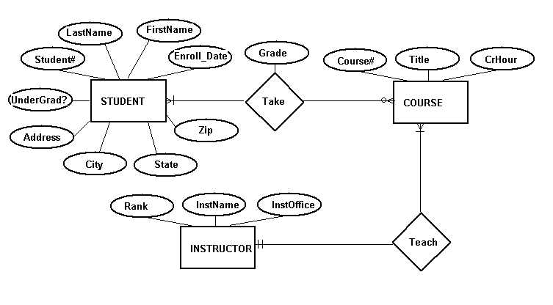
  - Explain the key differences between a view and a regular table. Provide a practical example illustrating when it is beneficial to use a view rather than a regular table and vice versa. Analyze the implications of your example in terms of data management.
  - Given a relational Schema R(E, F,G,H) and set of Function Dependency
FD = {F → E, EH → FG, G → EFH}. Find the canonical cover?

- Discuss the correspondence between the ER model constructs and the relational model constructs. Show how each ER model construct can be mapped to the relational model.
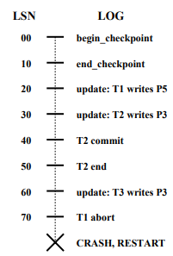
- Briefly answer the following questions:
    - What are the roles of the Analysis, Redo and Undo phases in ARIES?
    - Consider the execution shown in next figure:
      - What is done during Analysis? (Be precise about the points at which Analysis begins and ends and describe the contents of any tables constructed in this phase.)
      - What is done during Redo? (Be precise about the points at which Redo begins and ends.)
      - What is done during Undo? (Be precise about the points at which Undo begins and ends.)
- Create a trigger for the table Student so that it should get triggered when the user performs insertion operations like inserting a new tuple with student name, student roll number, and mark then the grade of the mark must be automatically updated in the grade column.
- Consider the three transactions T1, T2, and T3, and the schedules S1 and S2 given below. Draw the serializability (precedence) graphs for S1 and S2, and
state whether each schedule is serializable or not. If a schedule is serializable,
write down the equivalent serial schedule(s).
T1: r1 (X); r1 (Z); w1 (X);
T2: r2 (Z); r2 (Y); w2 (Z); w2 (Y);
T3: r3 (X); r3 (Y); w3 (Y);
S1: r1 (X); r2 (Z); r1 (Z); r3 (X); r3 (Y); w1 (X); w3 (Y); r2 (Y); w2 (Z); w2 (Y); S2: r1 (X); r2 (Z); r3 (X); r1 (Z); r2 (Y); r3 (Y); w1 (X); w2 (Z); w3 (Y); w2 (Y);
- What is the system log used for? What are the typical kinds of records in a system log? What are transaction commit points, and why are they important?

